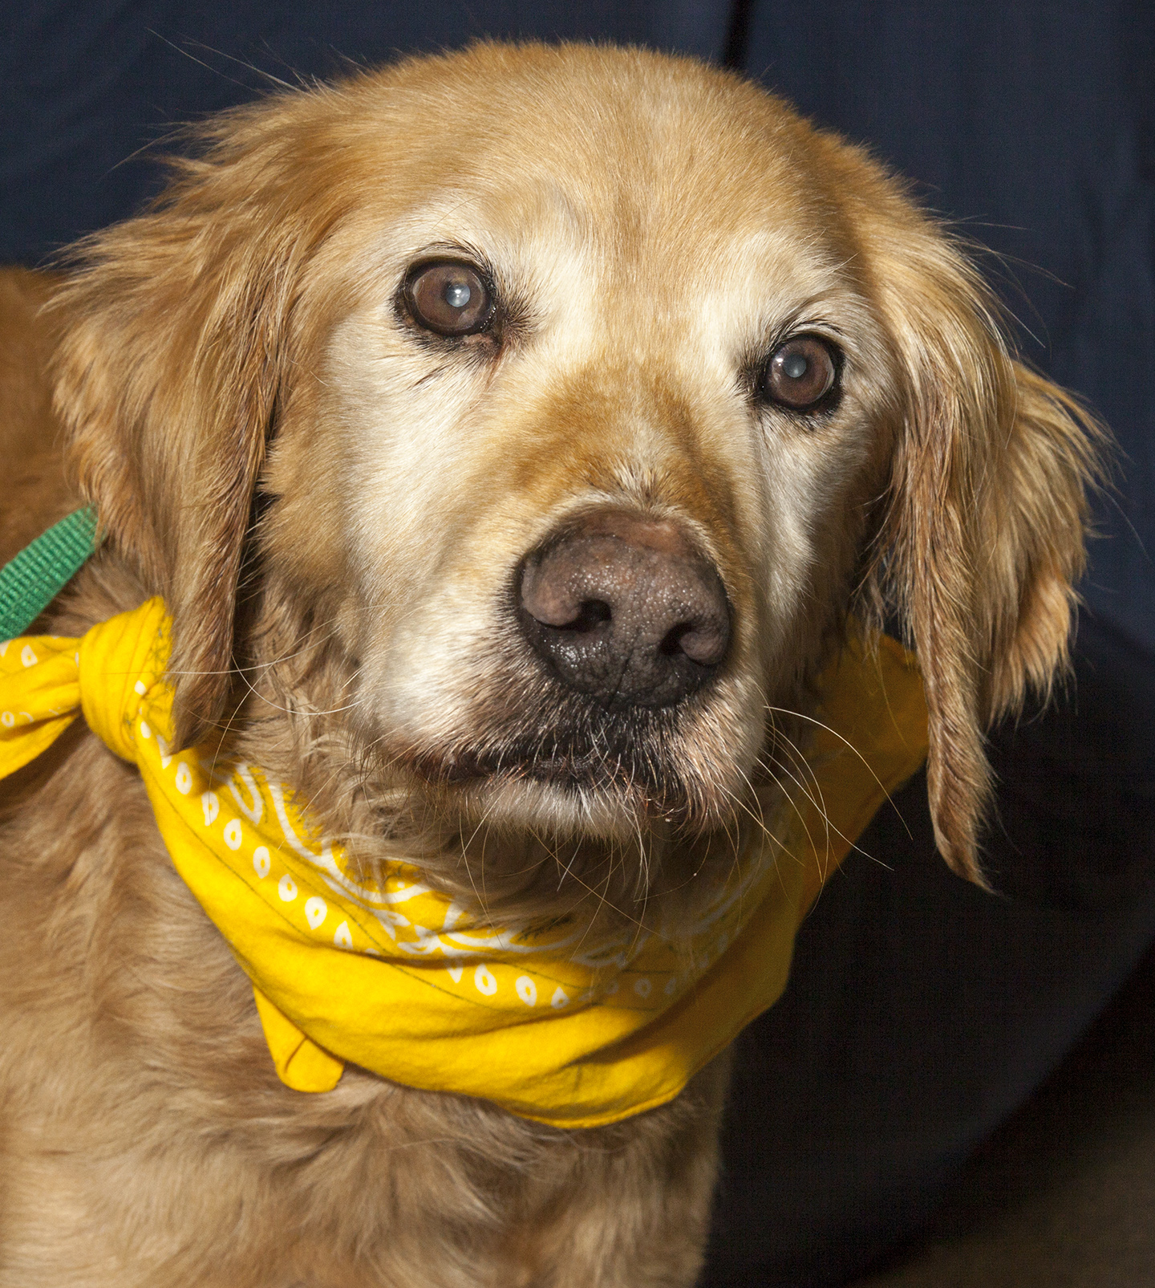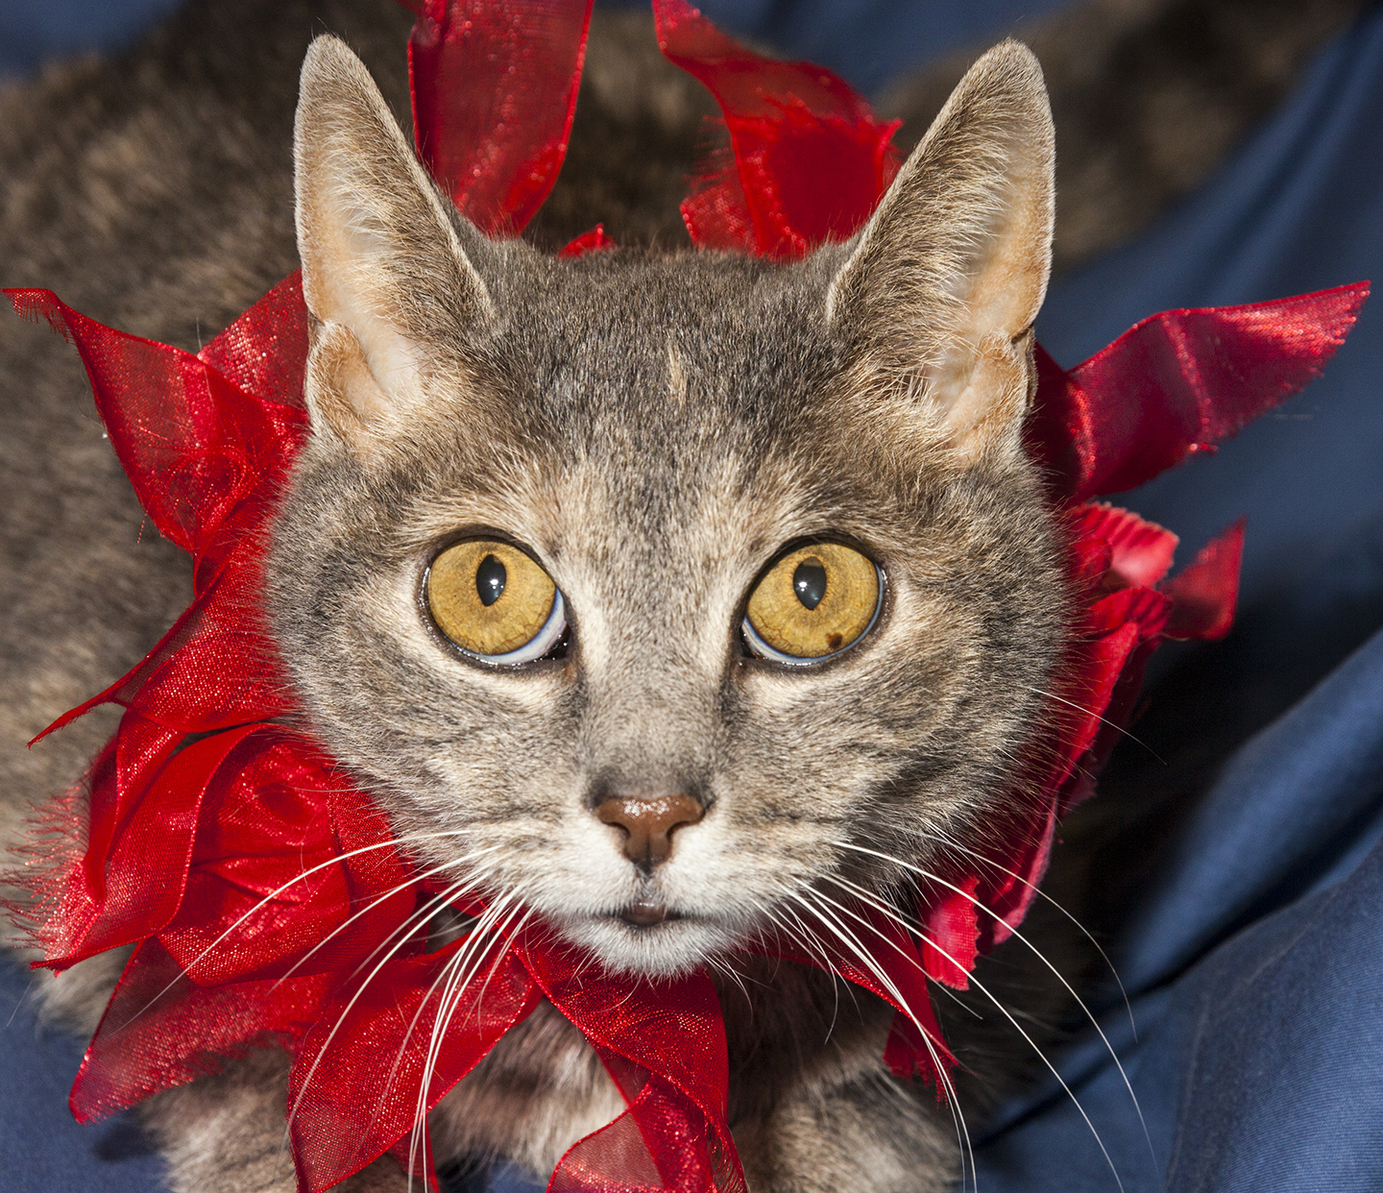

CRITTER CORNER
www.CritterCorner.org
Why not start your pet search at your local county animal shelter? For more information about our
featured pets, call 732-657-8086 and/or visit the Petfinder site at http://www.petfinder.com/shelters/NJ62.html

Thinking about adopting? Now is the time!

Adopt a Pet, Save a Life! Alll of our pets are vaccinated, neutered, and chipped before being adopted? Adopting a pet is not only a great way to find your new best friend; it’s also a great value!

Comet—Golden Retriever Mix
He's a Find!

Comet is a wonderful, 5 year old, male, smaller Golden Retriever mix. Comet is super sweet and has a kind and gentle nature. He would do well with another calm dog or as an "only" and doesn't seem to be bothered by cats. He's a find! Call 732-657-8086 to find out more.

Ginger—Dilute Torti DSH
Little Cutie Pie!

Ginger is a petite, adult, female, dilute torti domestic short hair (DSH). Ginger is an easy going, serene, happy cat. She is a little cutie pie that will make a great companion. Ginger purrs with any attention - a real sweetie. Call 732-657-8086 to find out more.
.

This is an independent publication by Mitch Geier and Betsy Lane and is
not meant to be construed as an official publication of the Ocean County Health Department.
2/23/2013
Ocean County Animal Facility

Northern Ocean County Animal Facility Southern Ocean County Animal Facility
615 Freemont Avenue 360 Haywood Road
Jackson, NJ 08527 Manahawkin, NJ 08050
    - 609-978-0127

Featured pets are at the Ocean County Animal Facility-North—open 7 days a week (except holidays) from 1 PM to 4 PM and 1 PM to 6:30 PM Wednesdays —and can be reached at 732-657-8086.


