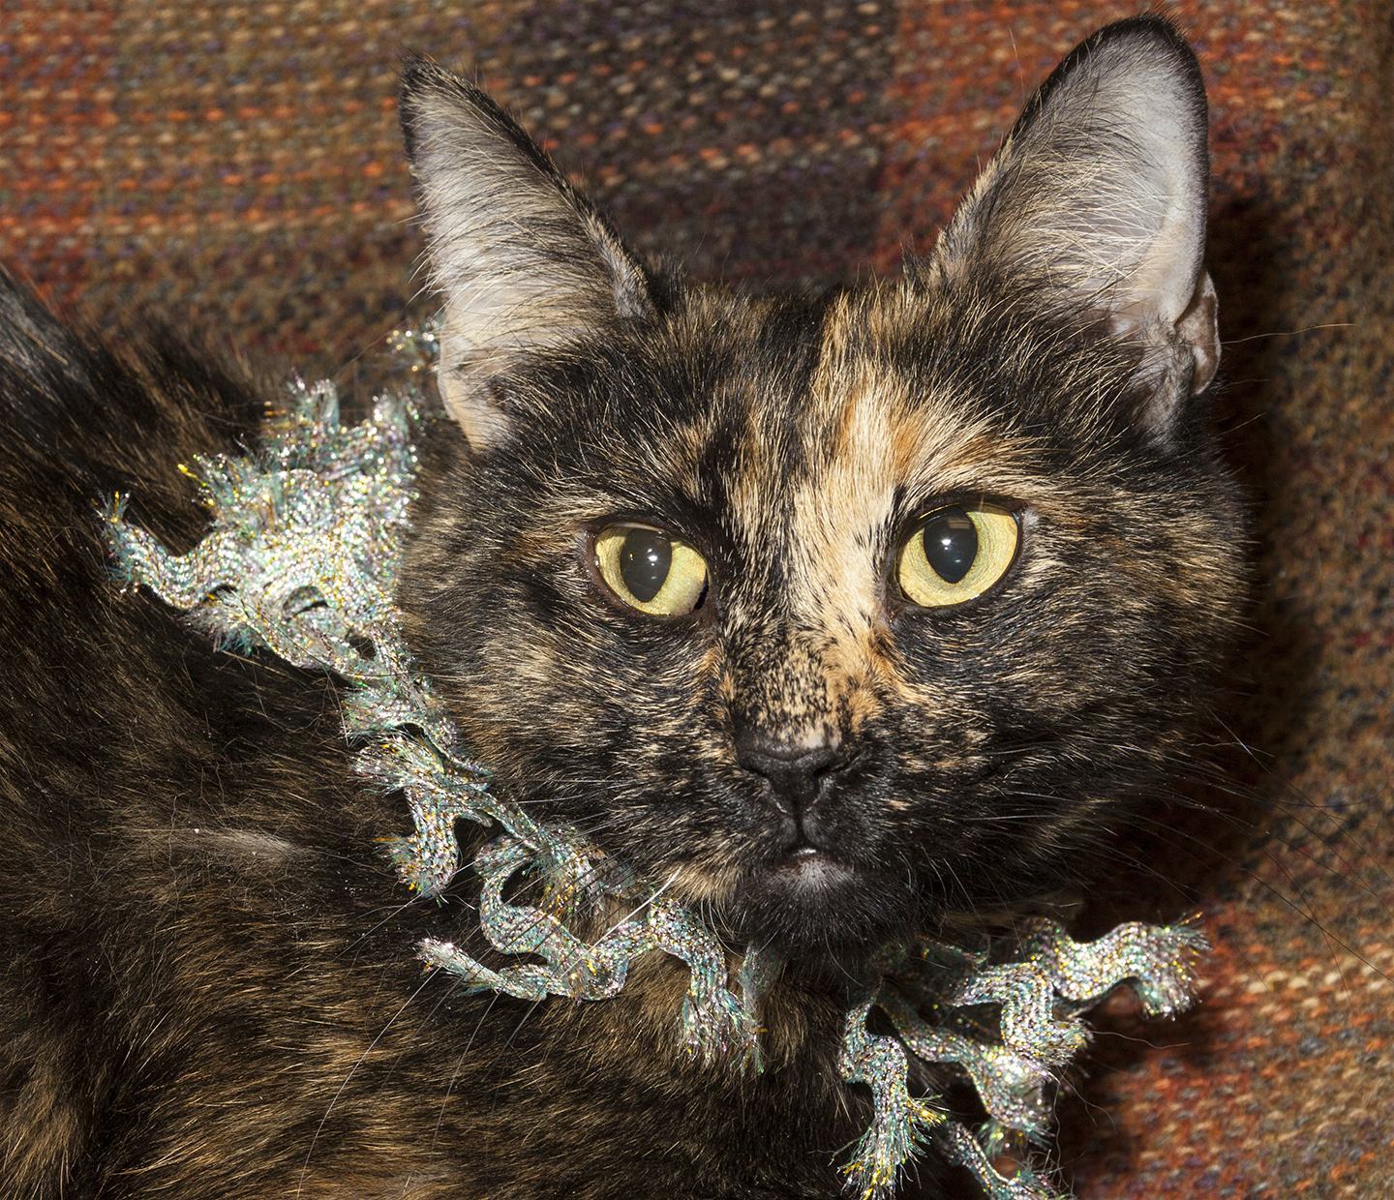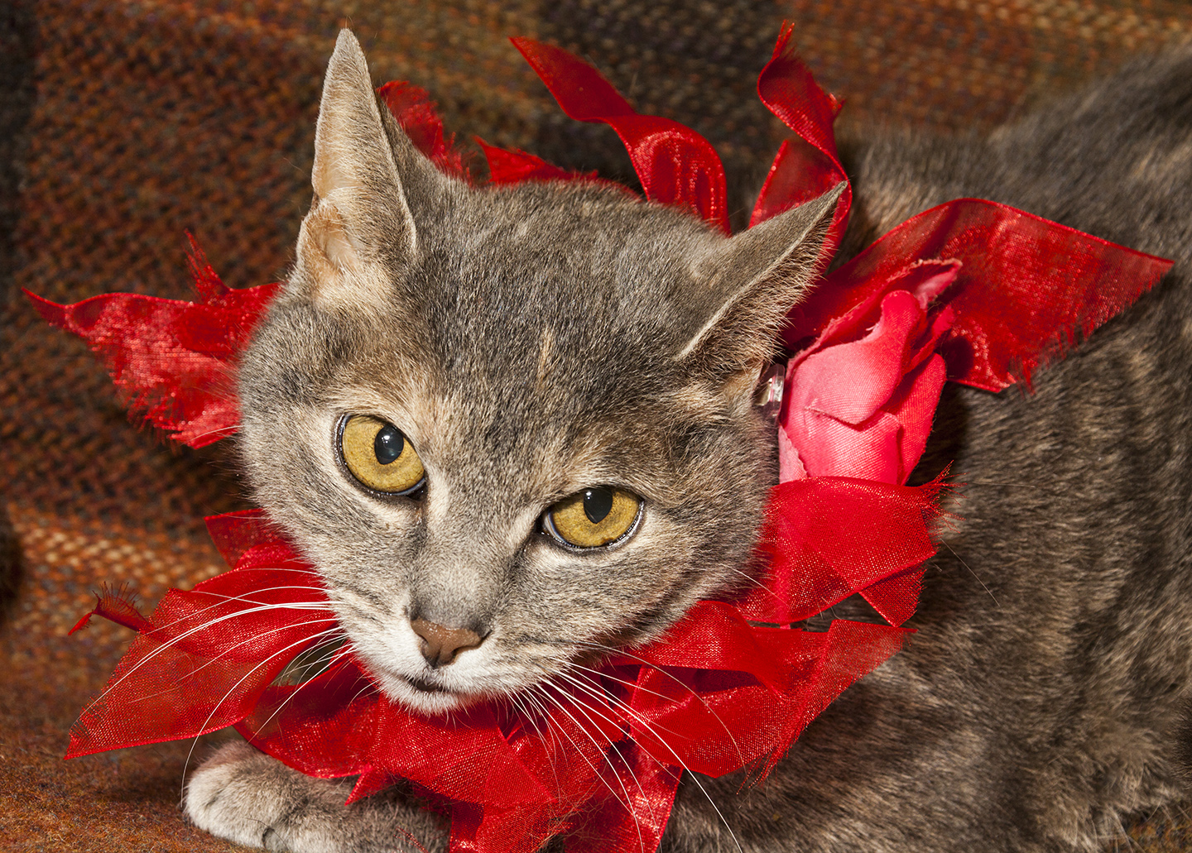

CRITTER CORNER
www.CritterCorner.org
Why not start your pet search at your local county animal shelter? For more information about our
featured pets, call 732-657-8086 and/or visit the Petfinder site at http://www.petfinder.com/shelters/NJ62.html

Spring is here and we'll soon have many more cats in house. If you want a cat or kitten, now is a great time to add to your family. Thinking about adopting? Now is the time!

Adopt a Pet, Save a Life! Alll of our pets are vaccinated, neutered, and chipped before being adopted? Adopting a pet is not only a great way to find your new best friend; it’s also a great value!

Caramel—Torti DSH
Precious Little Sweetie Pie!

Caramel is a petite, 2 year old, female, torti domestic short hair (DSH). Caramel is a pretty, sweet, serene little girl. She is an easy going kitty who hope to find her forever home soon. Caramel is a precious little sweetie pie! Call 732-657-8086 to find out more.

Ginger—Dilute Torti DSH
The Perfect Cat!

Ginger is an adult dilute torti domestic short hair (DSH) and is the perfect cat! She only wants to curl up on a chair or sit in the window and watch the world go by. Ginger is a super sweet girl who loves everyone and has the biggest, soulful eyes. Call 732-657-8086 to find out more.

.

This is an independent publication by Mitch Geier and Betsy Lane and is
not meant to be construed as an official publication of the Ocean County Health Department.
3/24/2013
Ocean County Animal Facility

Northern Ocean County Animal Facility Southern Ocean County Animal Facility
615 Freemont Avenue 360 Haywood Road
Jackson, NJ 08527 Manahawkin, NJ 08050
    - 609-978-0127

Featured pets are at the Ocean County Animal Facility-North—open 7 days a week (except holidays) from 1 PM to 4 PM and 1 PM to 6:30 PM Wednesdays —and can be reached at 732-657-8086.


