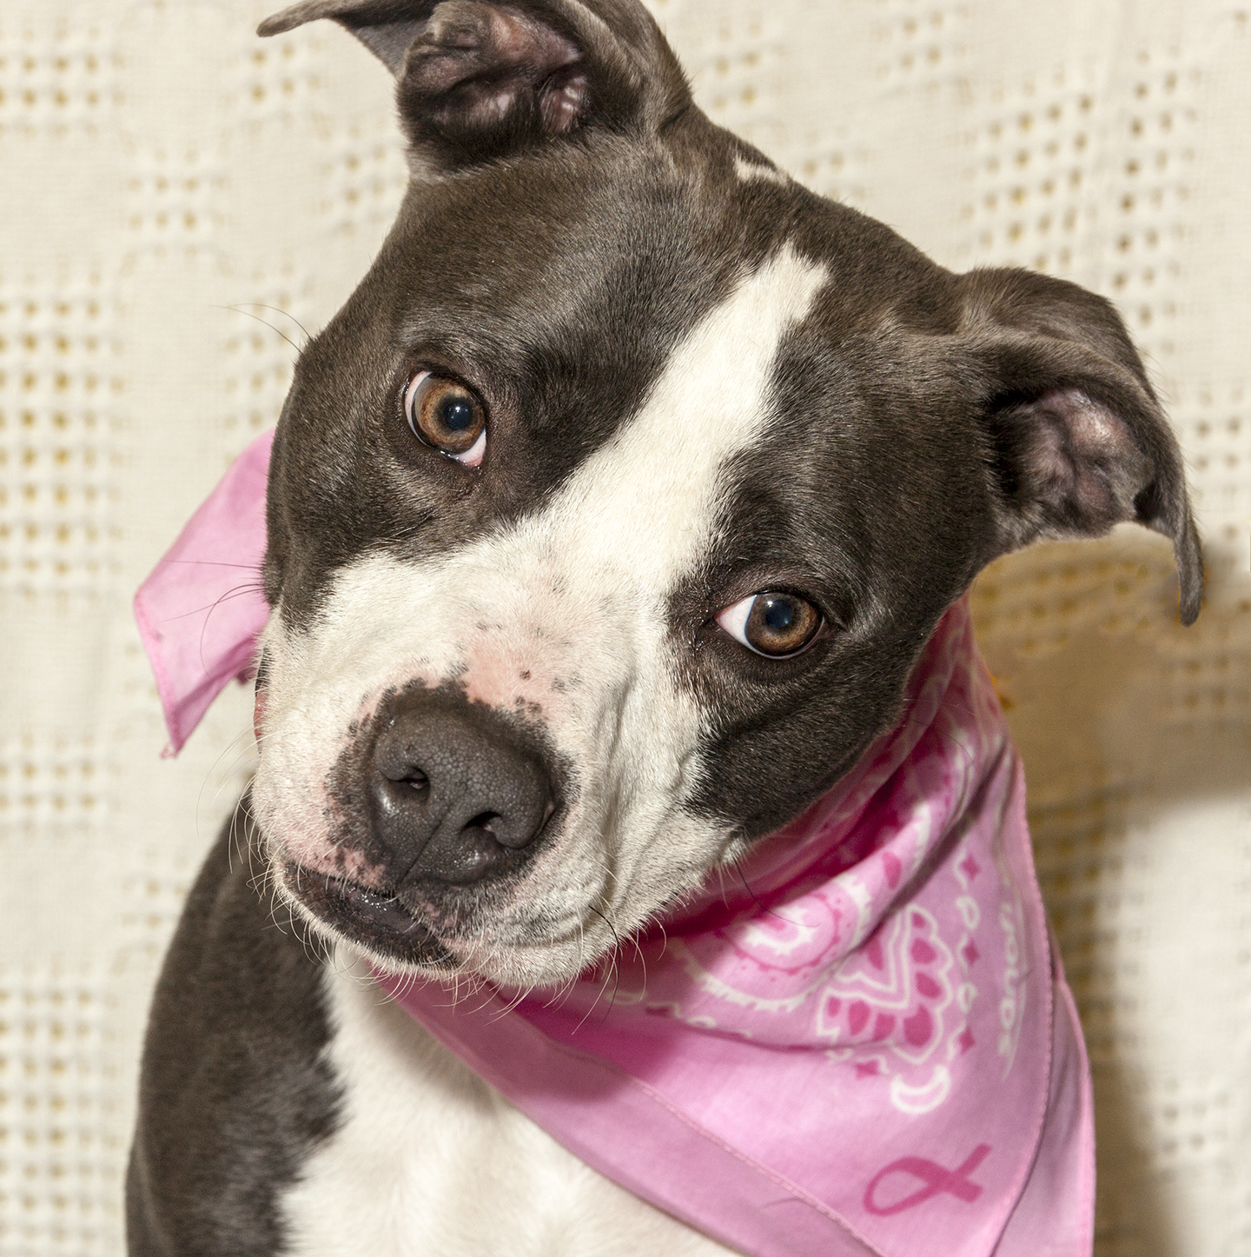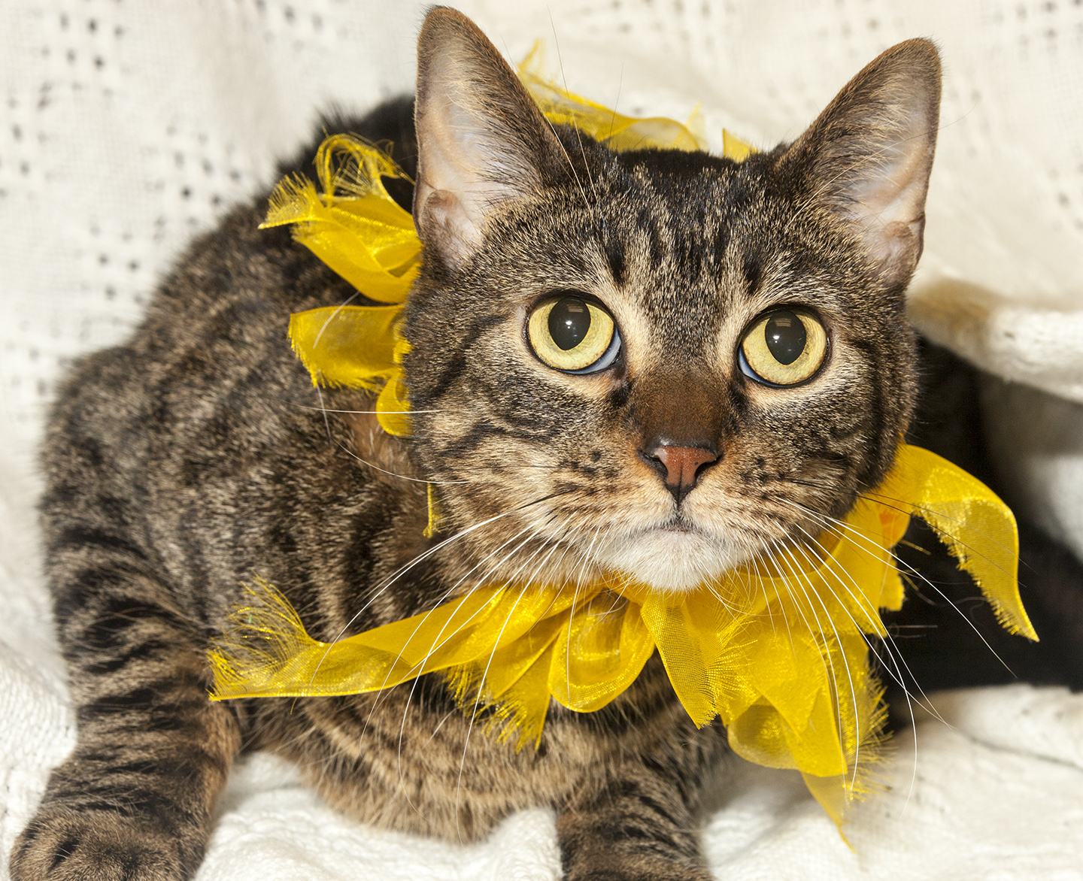

CRITTER CORNER
www.CritterCorner.org
Why not start your pet search at your local county animal shelter? For more information about our
featured pets, call 732-657-8086 and/or visit the Petfinder site at http://www.petfinder.com/shelters/NJ62.html

Spring is here and we'll soon have many more cats in house. If you want a cat or kitten, now is a great time to add to your family. Thinking about adopting? Now is the time!

Adopt a Pet, Save a Life! Alll of our pets are vaccinated, neutered, and chipped before being adopted? Adopting a pet is not only a great way to find your new best friend; it’s also a great value!

Marla—American Mix
Gives Great Kisses!

Marla is a 1 year old, female, gray and white, American Mix. Marla is a sweetie pie! She is fun, affectionate, and loves attention. Marla is young and high energy. She gives great kisses. Call 732-657-8086 to find out more.

Egypt—Tiger/Tabby DSH
Calm, Loving, and Cuddly!

Egypt is a 5 year old, female, brown tiger/tabby domestic short hair (DSH). Egypt is a precious little girl. She is calm, loving, and cuddly. She is a little shy at first, but warms up quickly. Call 732-657-8086 to find out more.

.

.

This is an independent publication by Mitch Geier and Betsy Lane and is
not meant to be construed as an official publication of the Ocean County Health Department.
3/31/2013
Ocean County Animal Facility

Northern Ocean County Animal Facility Southern Ocean County Animal Facility
615 Freemont Avenue 360 Haywood Road
Jackson, NJ 08527 Manahawkin, NJ 08050
    - 609-978-0127

Featured pets are at the Ocean County Animal Facility-North—open 7 days a week (except holidays) from 1 PM to 4 PM and 1 PM to 6:30 PM Wednesdays —and can be reached at 732-657-8086.


