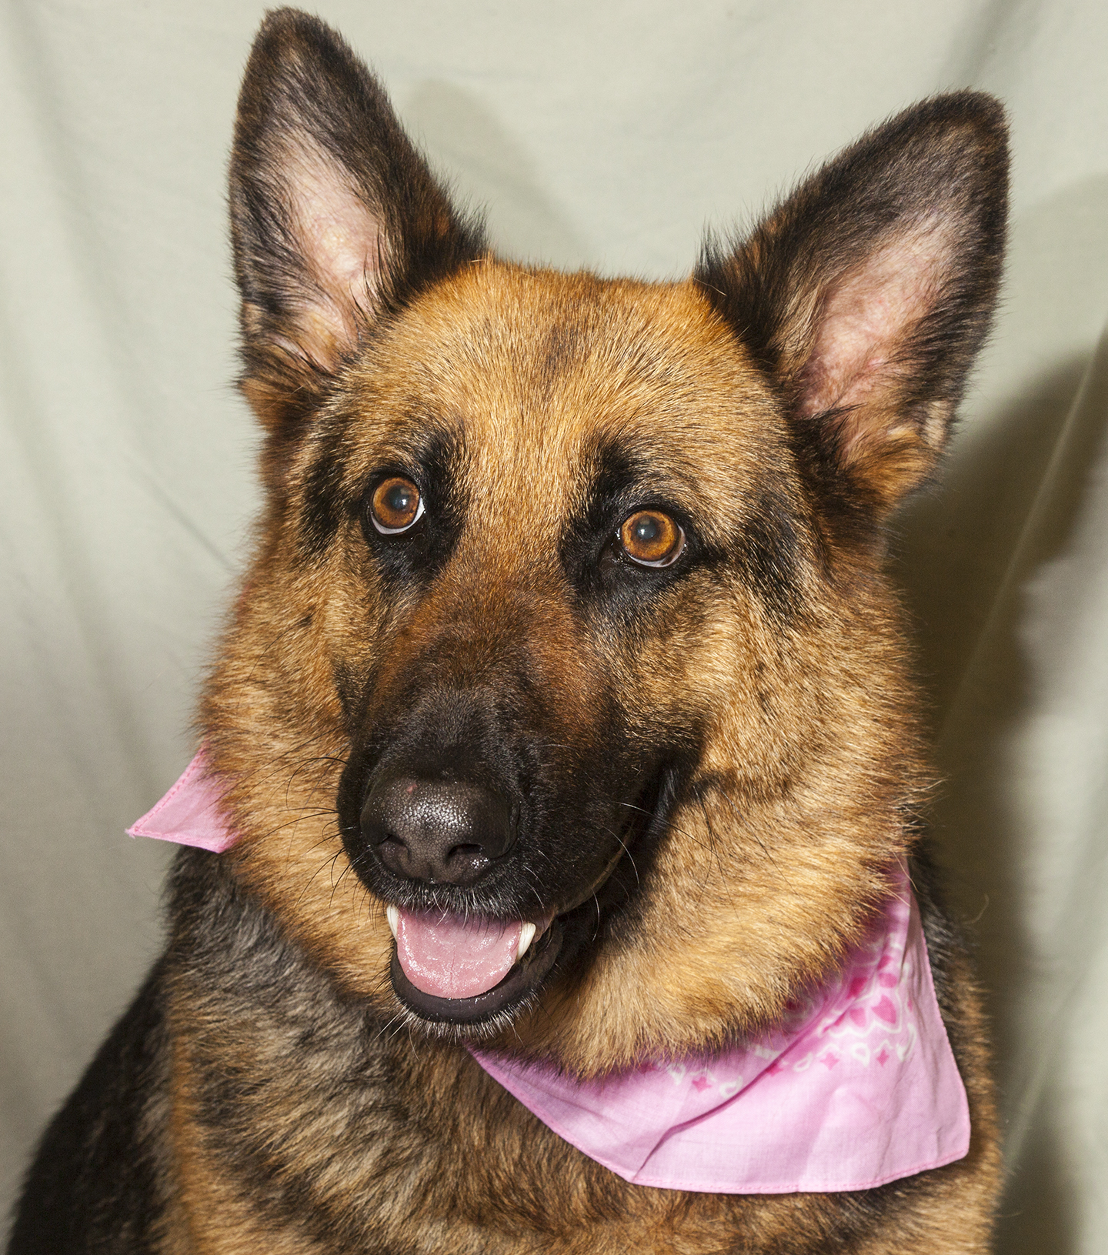

CRITTER CORNER
www.CritterCorner.org
Why not start your pet search at your local county animal shelter? For more information about our
featured pets, call 732-657-8086 and/or visit the Petfinder site at http://www.petfinder.com/shelters/NJ62.html

Kittens, kittens, kittens, and more kittens. It is officially "kitten season."
If you've been thinking about adopting a cat - now is the time. Adopt a pet; save a life.

Adopt a Pet, Save a Life! Alll of our pets are vaccinated, neutered, and chipped before being adopted? Adopting a pet is not only a great way to find your new best friend; it’s also a great value!

Mila—German Shepherd
Sweet Girl!

Mila is a beautiful, 3 year old, female, German Shepherd. Mila is such a sweet girl and just a great dog! She is calm, obedient, well behaved, and knows a number of commands. She will make a wonderful pet. Call 732-657-8086 to find out more.

Maci—Gray with White DSH
Cutie Pie!

Maci is an adult, female, gray with white, domestic short hair (DSH). Maci is a little cutie pie. She is easy going, affectionate, and fun. Maci has an adorable white "mustache" and bib. Call 732-657-8086 to find out more.
.

This is an independent publication by Mitch Geier and Betsy Lane and is
not meant to be construed as an official publication of the Ocean County Health Department.
6/30/2013
Ocean County Animal Facility

Northern Ocean County Animal Facility Southern Ocean County Animal Facility
615 Freemont Avenue 360 Haywood Road
Jackson, NJ 08527 Manahawkin, NJ 08050
    - 609-978-0127

Featured pets are at the Ocean County Animal Facility-North—open 7 days a week (except holidays) from 1 PM to 4 PM and 1 PM to 6:30 PM Wednesdays —and can be reached at 732-657-8086.


