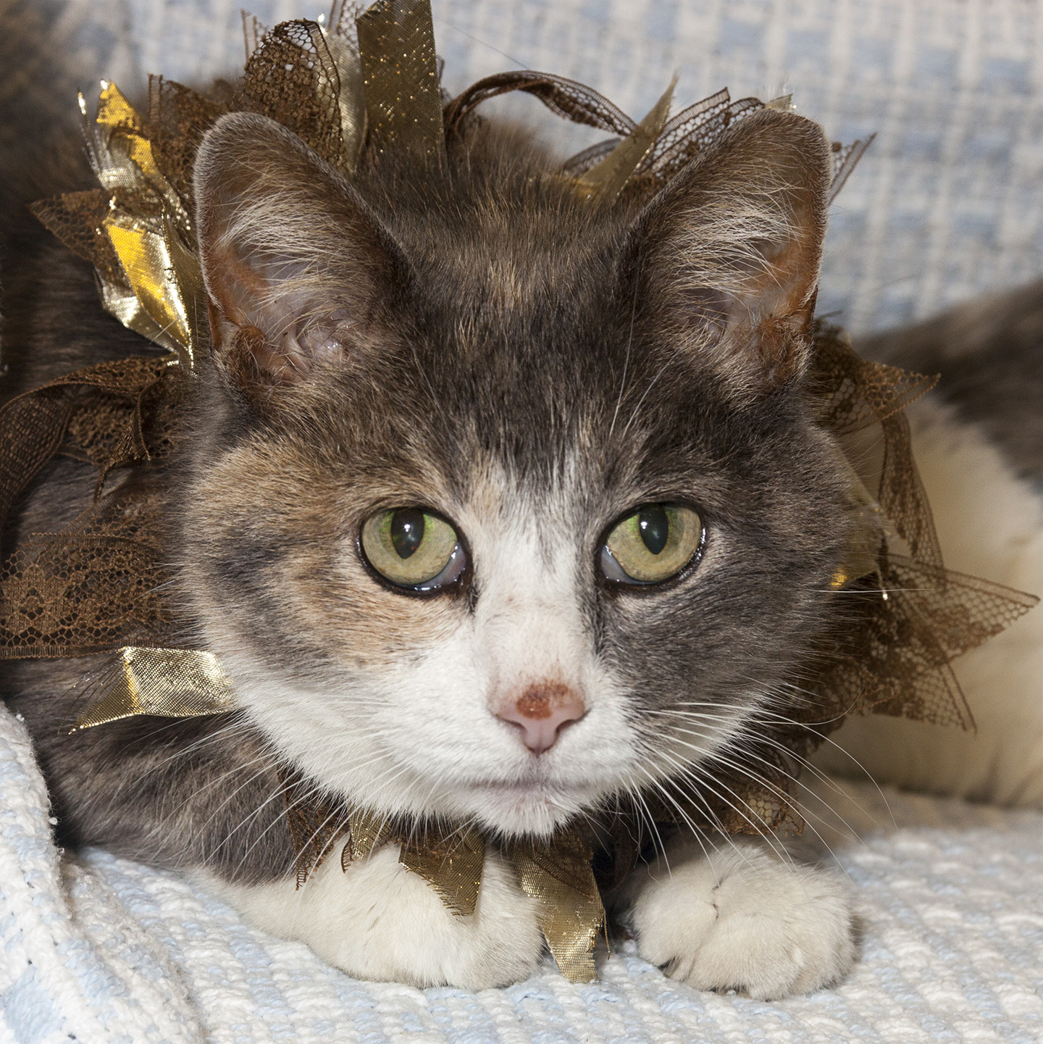

CRITTER CORNER
www.CritterCorner.org
Why not start your pet search at your local county animal shelter? For more information about our
featured pets, call 732-657-8086 and/or visit the Petfinder site at http://www.petfinder.com/shelters/NJ62.html

Kittens, kittens, kittens, and more kittens. It is officially "kitten season."
If you've been thinking about adopting a cat - now is the time. Adopt a pet; save a life.

Adopt a Pet, Save a Life! Alll of our pets are vaccinated, neutered, and chipped before being adopted? Adopting a pet is not only a great way to find your new best friend; it’s also a great value!

Malcolm—Boxer
Malcolm in the Middle!

Malcolm is an adult, male, fawn and black coated, Boxer. Malcolm is such a sweet boy. He is very calm and loves to be around people. He walks well on a leash and gets along well with other dogs and cats. Call 732-657-8086 to find out more.

Tinkerbell—Dilute Torti DSH
Total Sweetheart!

Tinkerbell is an adult, female, gray dilute torti domestic short hair (DSH). Tinkerbell is a total sweetheart. She is easy going, loving, cuddly, and purrs like a little motorboat. Call 732-657-8086 to find
out more.
.

This is an independent publication by Mitch Geier and Betsy Lane and is
not meant to be construed as an official publication of the Ocean County Health Department.
7/21/2013
Ocean County Animal Facility

Northern Ocean County Animal Facility Southern Ocean County Animal Facility
615 Freemont Avenue 360 Haywood Road
Jackson, NJ 08527 Manahawkin, NJ 08050
    - 609-978-0127

Featured pets are at the Ocean County Animal Facility-North—open 7 days a week (except holidays) from 1 PM to 4 PM and 1 PM to 6:30 PM Wednesdays —and can be reached at 732-657-8086.


