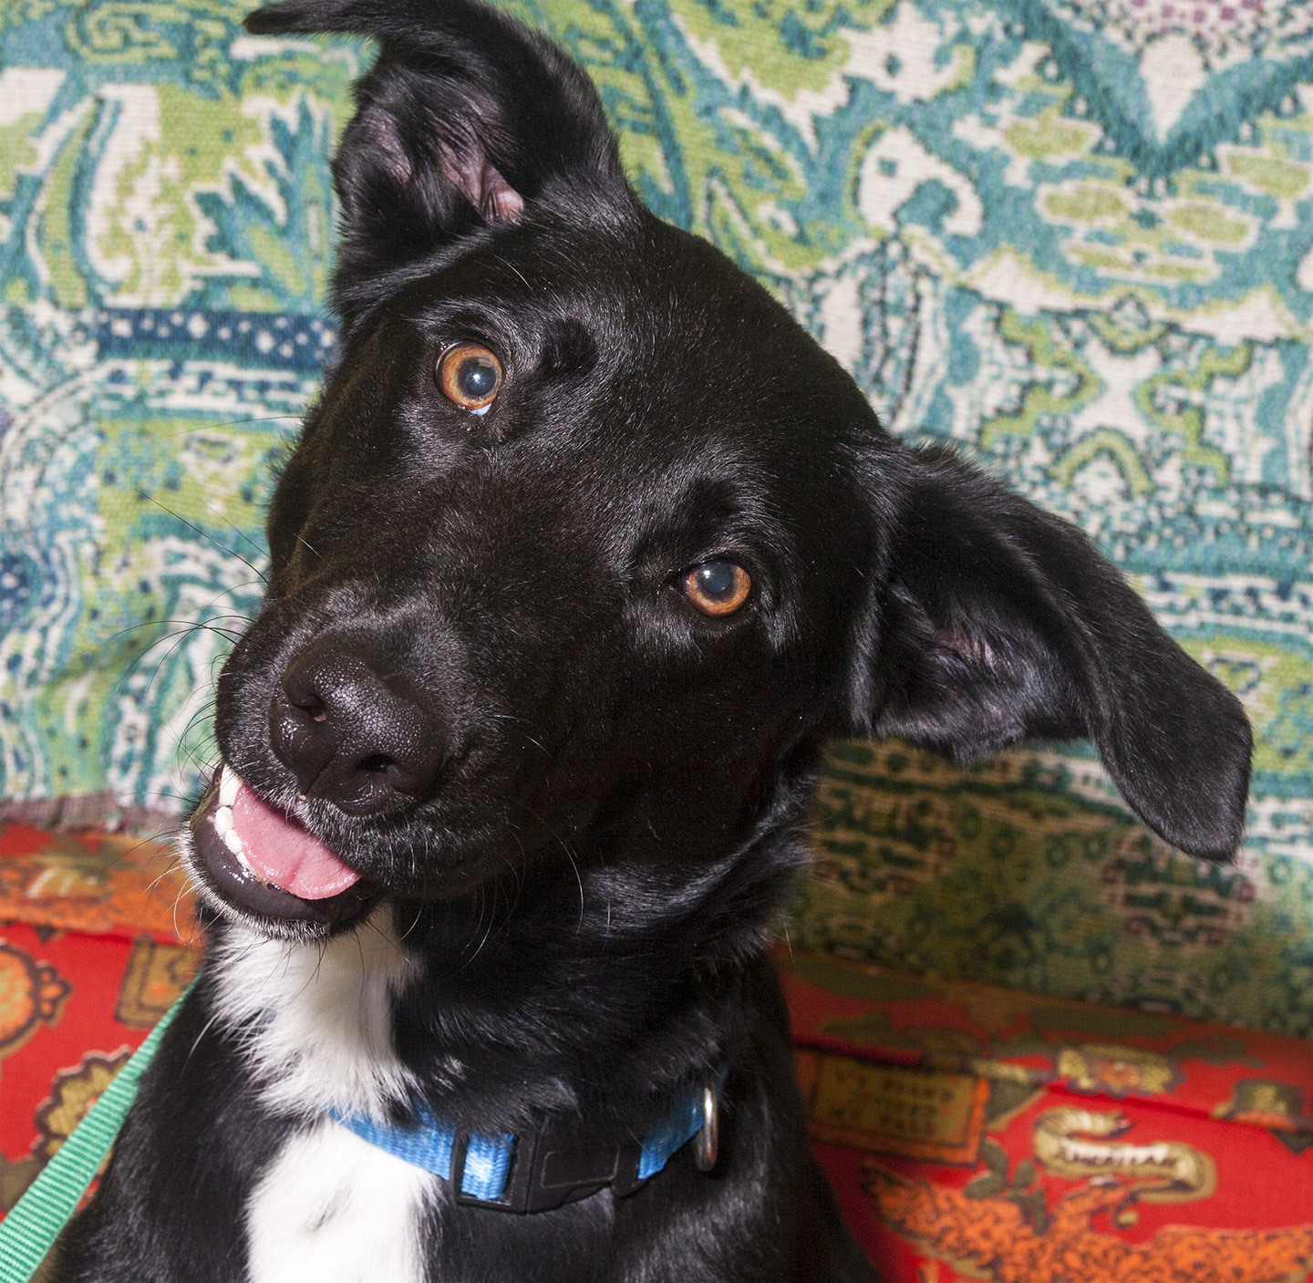

CRITTER CORNER
www.CritterCorner.org
Why not start your pet search at your local county animal shelter? For more information about our
featured pets, call 732-657-8086 and/or visit the Petfinder site at http://www.petfinder.com/shelters/NJ62.html

We have a number of kittens, cats, smaller dogs, and breeds at the shelter.
If you've been thinking about adopting - now is the time. Adopt a pet; save a life.

Adopt a Pet, Save a Life! Alll of our pets are vaccinated, neutered, and chipped before being adopted? Adopting a pet is not only a great way to find your new best friend; it’s also a great value!

Nina—Border Collie
Friendly & Social Girl!

Nina is a young adult (~1 1/2 year old), female, black and white, Border Collie. Nina is a friendly and social girl. She loves attention and being petted. Nina needs training and is eager to please. She'll make a great pet for someone willing to give her some basic training. Call 732-657-8086 to find out more.

Sammy (aka Boots)
Black and White DSH—“Adorable!

Sammy is a young (10 month old), male, black and white, domestic short hair (DSH). Sammie is adorable! His nickname, Boots, is from his coat pattern that looks like his paws and belly were dipped in white paint. Call 732-657-8086 to find out more.

This is an independent publication by Mitch Geier and Betsy Lane and is
not meant to be construed as an official publication of the Ocean County Health Department.
9/15/2013
Ocean County Animal Facility

Northern Ocean County Animal Facility Southern Ocean County Animal Facility
615 Freemont Avenue 360 Haywood Road
Jackson, NJ 08527 Manahawkin, NJ 08050
    - 609-978-0127

Featured pets are at the Ocean County Animal Facility-North—open 7 days a week (except holidays) from 1 PM to 4 PM and 1 PM to 6:30 PM Wednesdays —and can be reached at 732-657-8086.


