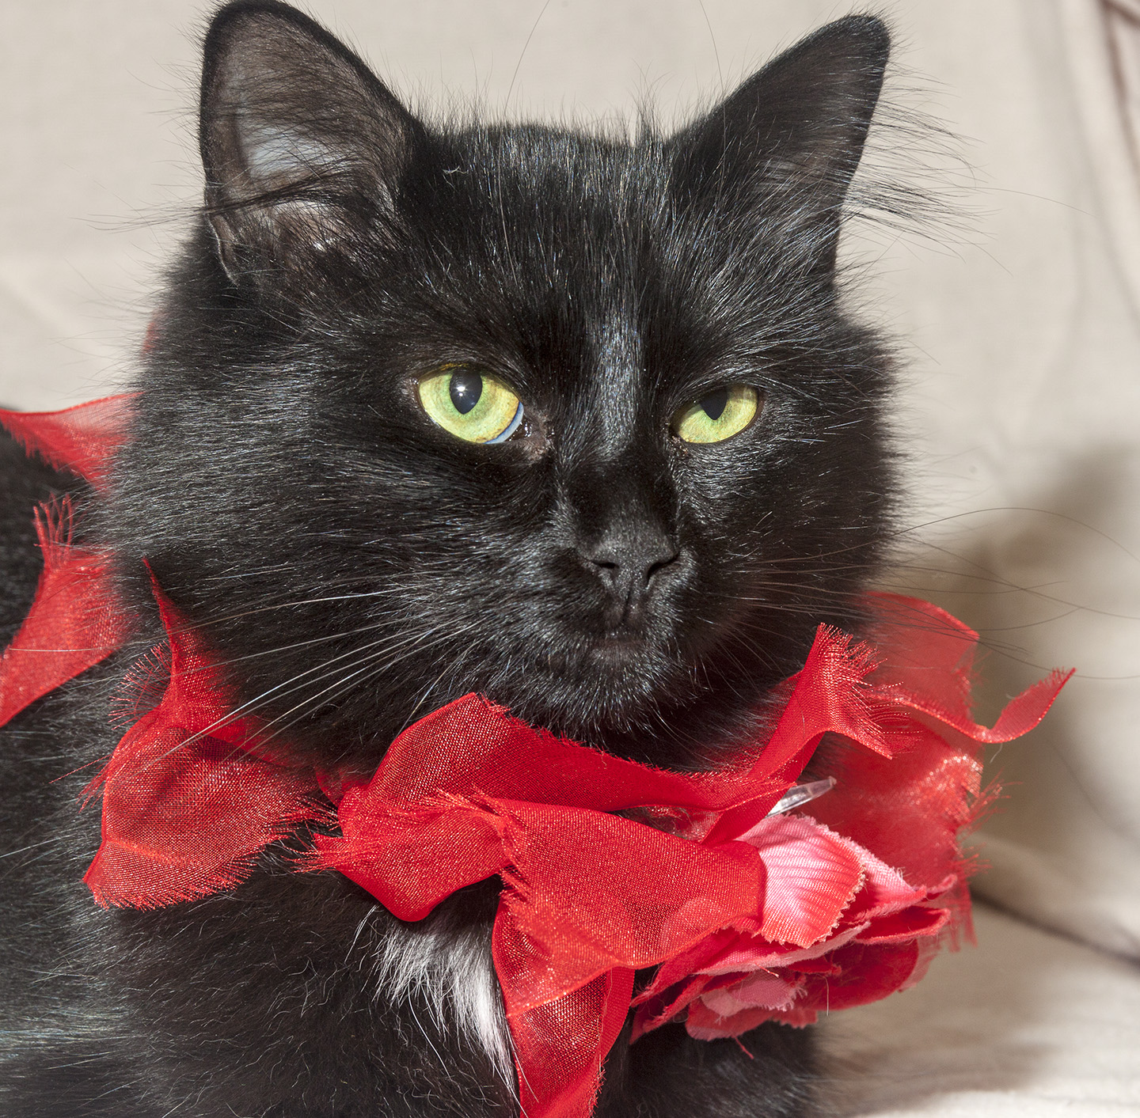

CRITTER CORNER
www.CritterCorner.org
Why not start your pet search at your local county animal shelter? For more information about our
featured pets, call 732-657-8086 and/or visit the Petfinder site at http://www.petfinder.com/shelters/NJ62.html

We have a number of kittens, cats, smaller dogs, and breeds at the shelter.
If you've been thinking about adopting - now is the time. Adopt a pet; save a life.

Adopt a Pet, Save a Life! Alll of our pets are vaccinated, neutered, and chipped before being adopted? Adopting a pet is not only a great way to find your new best friend; it’s also a great value!

Shaker—Beagle/Jack Russell Mix
Precious Little Thing!

Shaker is a smaller, adult, tri-color, male, Beagle/Jack Russell Mix. Shaker is a precious little thing. He is very timid in the shelter, but he does warm up with a little time. He is super sweet. Shaker really likes other dogs and would do well in a home with another dog or dogs. Call 732-657-8086 to find out more.

Tiffany—Ebony DMH
Great Cat!

Tiffany is a young, petite, female, ebony-coated, domestic medium hair (DMH). Tiffany is a great cat! She is calm, very loving, and adorable. Tiffany is a very attractive girl--her photos don't do her justice. She will make a wonderful pet. Call 732-657-8086 to find out more.

This is an independent publication by Mitch Geier and Betsy Lane and is
not meant to be construed as an official publication of the Ocean County Health Department.
10/27/2013
Ocean County Animal Facility

Northern Ocean County Animal Facility Southern Ocean County Animal Facility
615 Freemont Avenue 360 Haywood Road
Jackson, NJ 08527 Manahawkin, NJ 08050
    - 609-978-0127

Featured pets are at the Ocean County Animal Facility-North—open 7 days a week (except holidays) from 1 PM to 4 PM and 1 PM to 6:30 PM Wednesdays —and can be reached at 732-657-8086.

