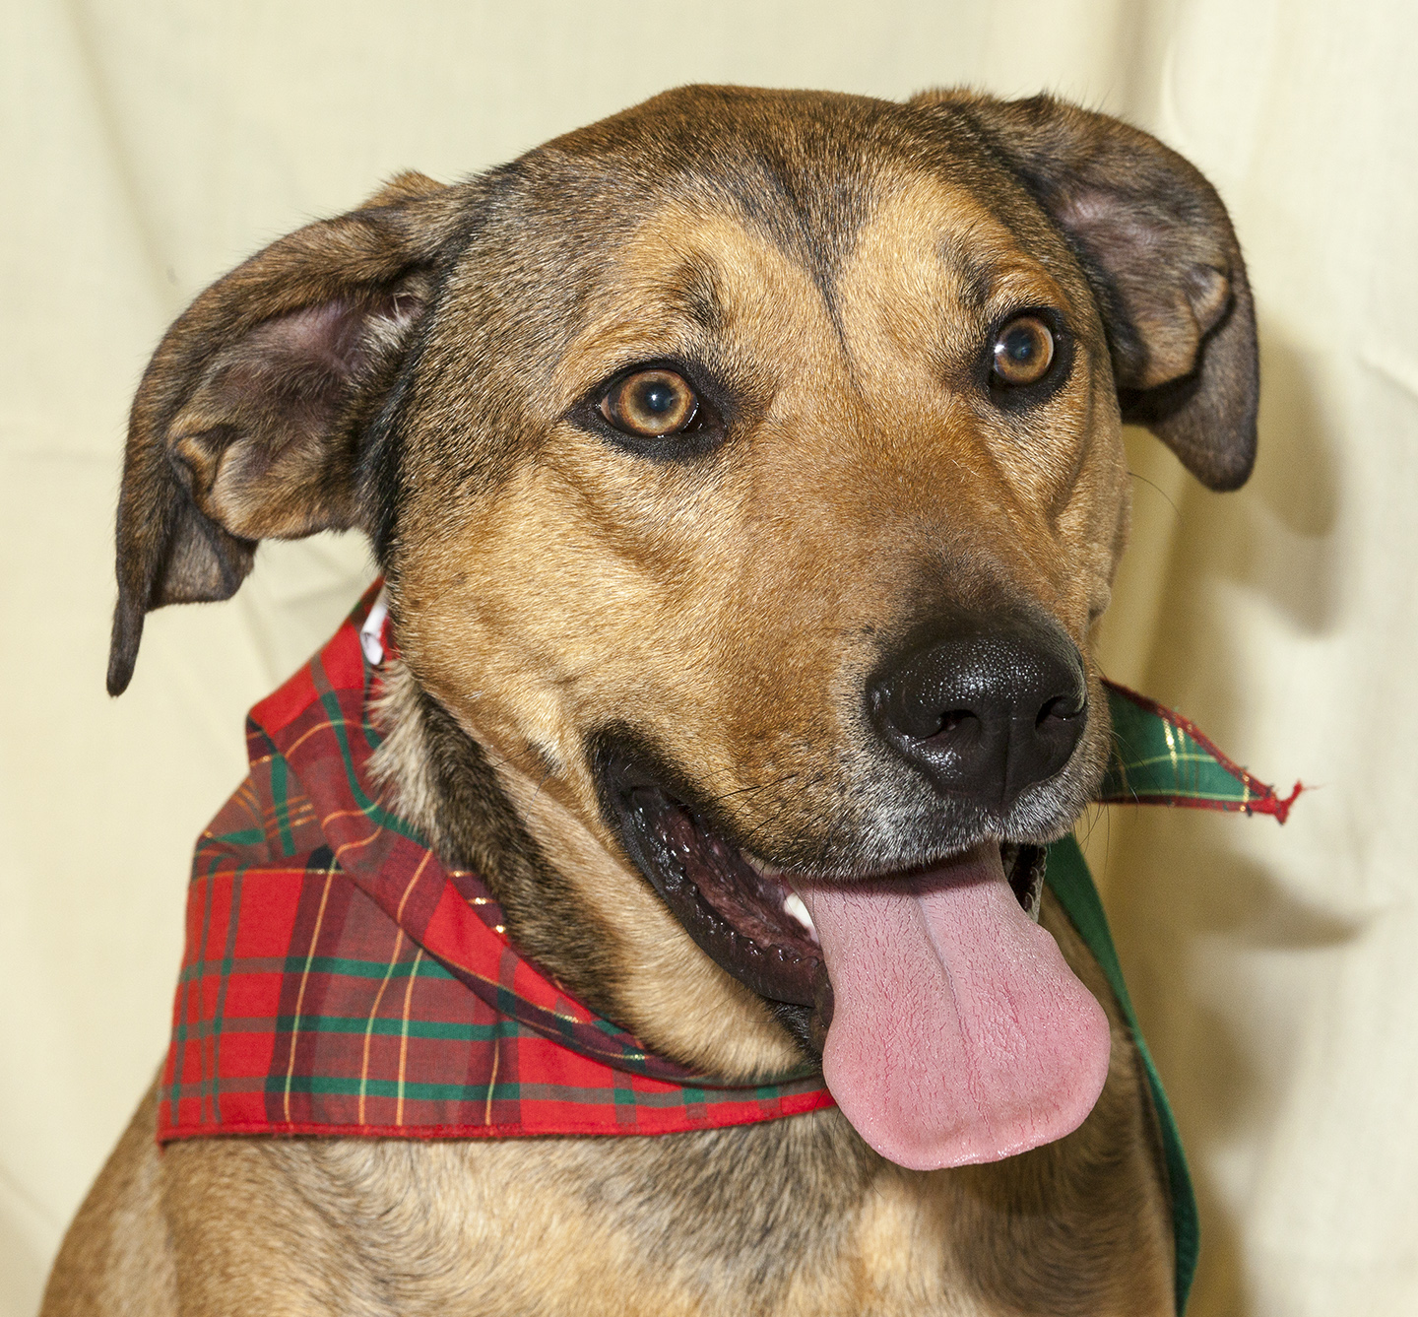

CRITTER CORNER
www.CritterCorner.org
Why not start your pet search at your local county animal shelter? For more information about our
featured pets, call 732-657-8086 and/or visit the Petfinder site at http://www.petfinder.com/shelters/NJ62.html

We have a number of kittens, cats, smaller dogs, and breeds at the shelter.
If you've been thinking about adopting - now is the time. Adopt a pet; save a life.

Adopt a Pet, Save a Life! Alll of our pets are vaccinated, neutered, and chipped before being adopted? Adopting a pet is not only a great way to find your new best friend; it’s also a great value!

Cruz—Mixed Breed
Adorable 1 1/2 Year Old!

Cruz is a 1 1/2 year old, male, tan and black, mixed breed. Cruz is adorable! He is smart, friendly, social, and loves people. Cruz knows several commands, including "sit," "down,", "come," and "stay." He has lived with children and is approved for home with children over 5. Call 732-657-8086 to find out more.

Foxie—Calico DMH
Front Declaw Sweetie!

Foxie is an 8 year old, female, white, tan, and black calico, domestic medium hair (DMH). Foxie is an in demand front declaw--so move quick if you're interested! She is calm, easy going, and affectionate. Foxie would do well in just about any home. Call 732-657-8086 to find out more.

This is an independent publication by Mitch Geier and Betsy Lane and is
not meant to be construed as an official publication of the Ocean County Health Department.
12/1/2013
Ocean County Animal Facility

Northern Ocean County Animal Facility Southern Ocean County Animal Facility
615 Freemont Avenue 360 Haywood Road
Jackson, NJ 08527 Manahawkin, NJ 08050
    - 609-978-0127

Featured pets are at the Ocean County Animal Facility-North—open 7 days a week (except holidays) from 1 PM to 4 PM and 1 PM to 6:30 PM Wednesdays —and can be reached at 732-657-8086.


