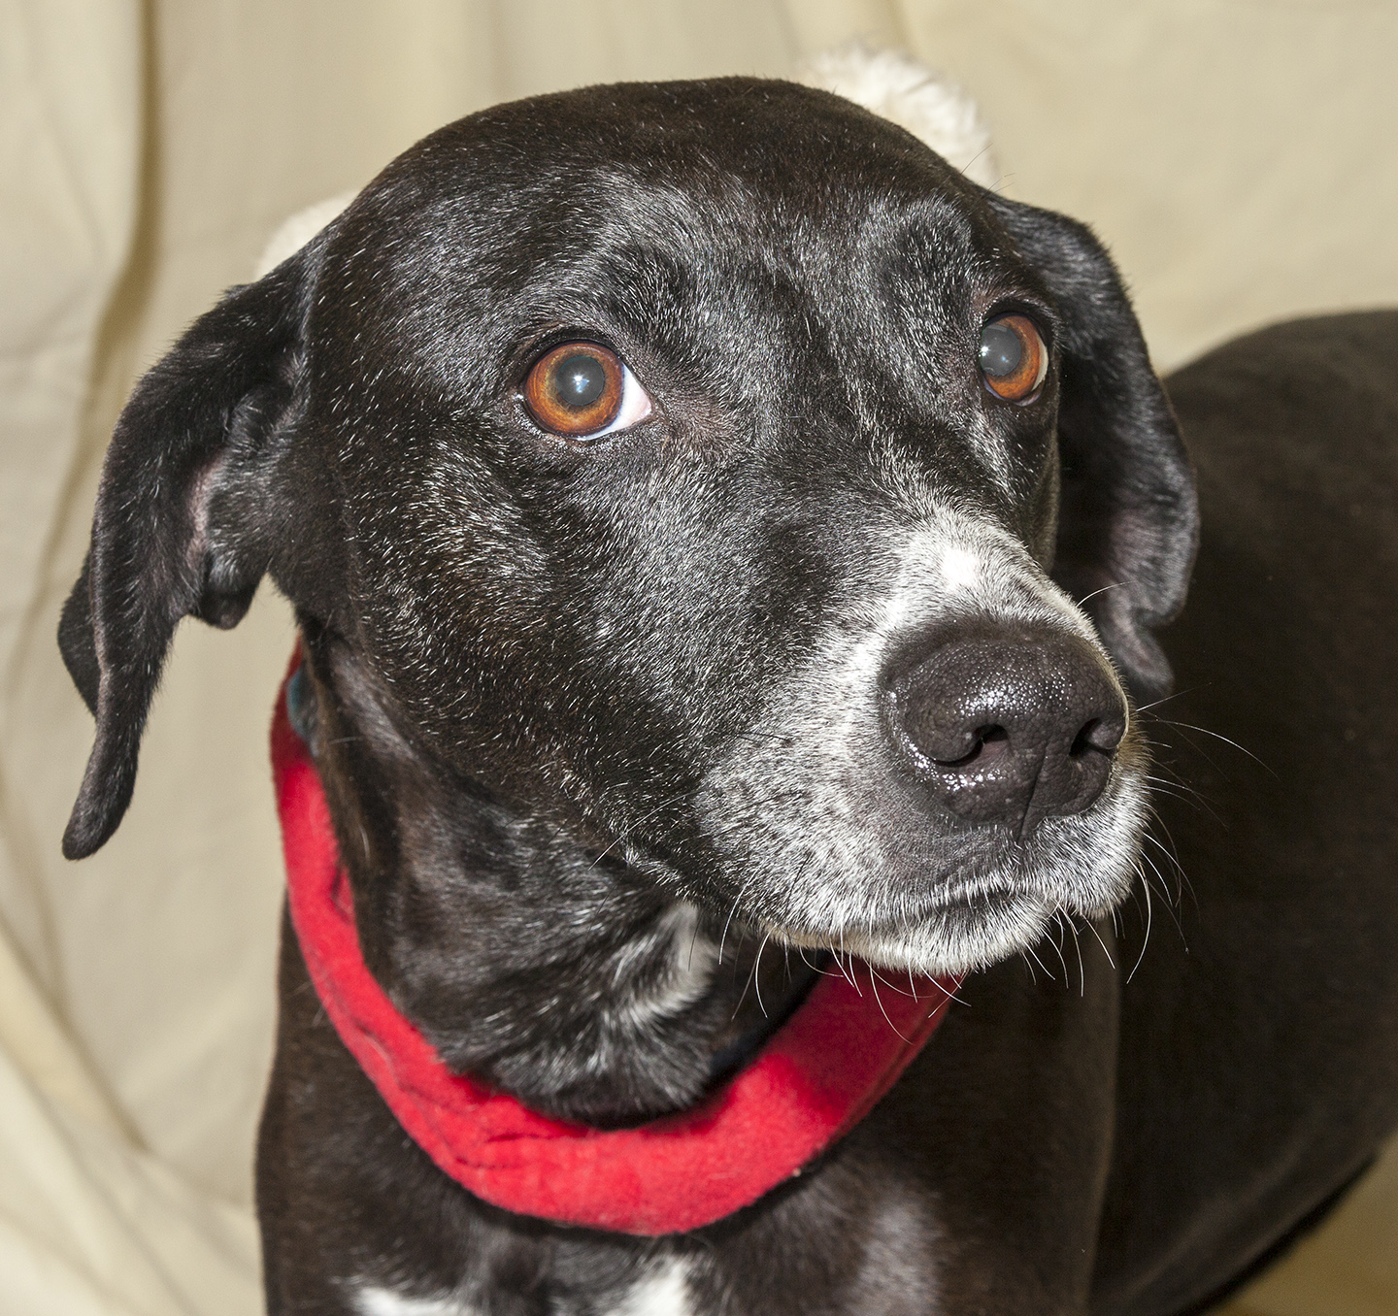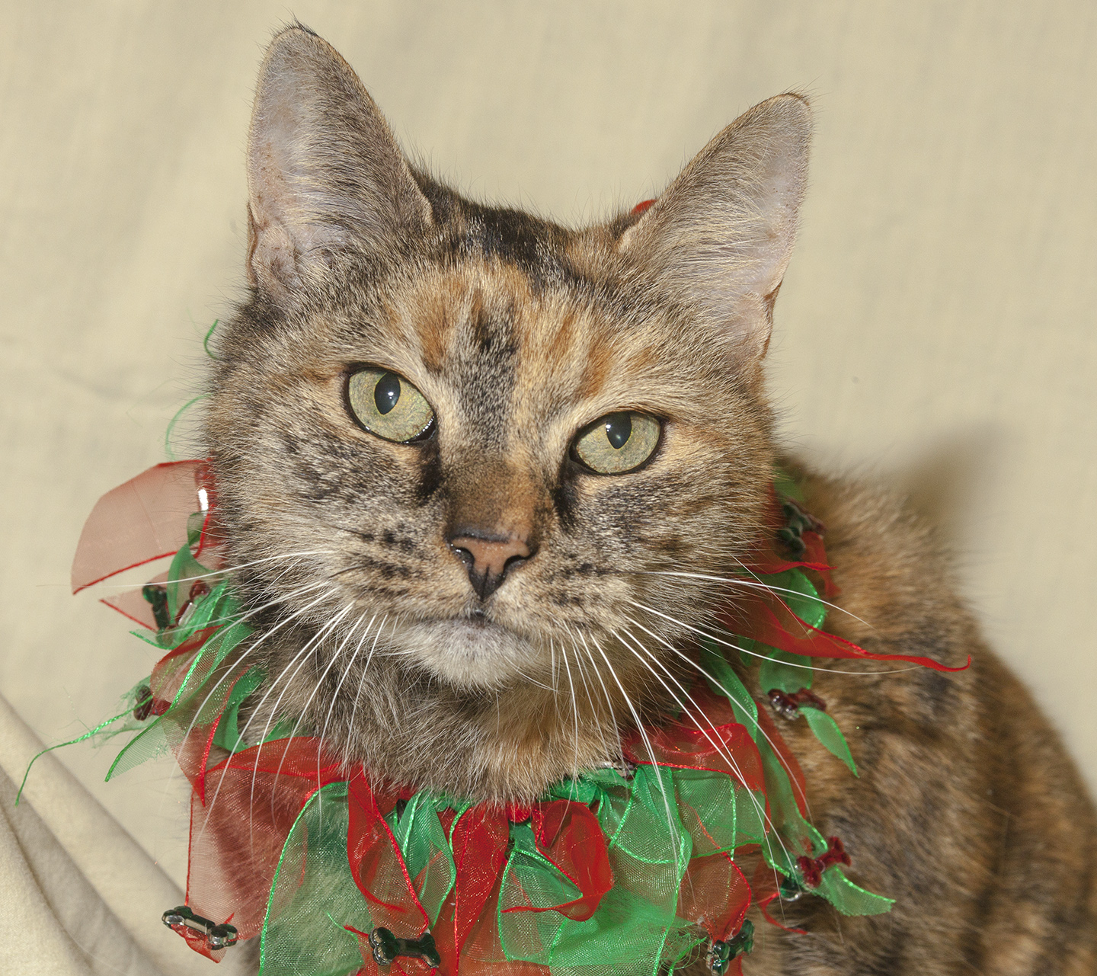

CRITTER CORNER
www.CritterCorner.org
Why not start your pet search at your local county animal shelter? For more information about our
featured pets, call 732-657-8086 and/or visit the Petfinder site at http://www.petfinder.com/shelters/NJ62.html

We have a number of kittens, cats, smaller dogs, and breeds at the shelter.
If you've been thinking about adopting - now is the time. Adopt a pet; save a life.

Adopt a Pet, Save a Life! Alll of our pets are vaccinated, neutered, and chipped before being adopted? Adopting a pet is not only a great way to find your new best friend; it’s also a great value!

Korty— Lab/Pointer Mix
Sweet, Sweet, Sweet!

Korty is an adult, female, black and white, Lab/Pointer Mix. Korty is calm, friendly, and sweet, sweet, sweet! She is shy at first and warms up quickly. Korty loves spending time with people and has lived with other cats and dogs. She would do best in a quiet home with children over the age of 10. Call 732-657-8086 to find out more.

Daisy Mae—Tri-color DSH
Little Love!

Daisy Mae is an adult, female, tri-color, domestic short hair (DSH). Daisy Mae is a little love! She is easy going, serene, and so happy to cuddle up to her human. She would love to be in her new forever home for the holidays. She even promises not to run up the tree. Call 732-657-8086 to find out more.

This is an independent publication by Mitch Geier and Betsy Lane and is
not meant to be construed as an official publication of the Ocean County Health Department.
12/15/2013
Ocean County Animal Facility

Northern Ocean County Animal Facility Southern Ocean County Animal Facility
615 Freemont Avenue 360 Haywood Road
Jackson, NJ 08527 Manahawkin, NJ 08050
    - 609-978-0127

Featured pets are at the Ocean County Animal Facility-North—open 7 days a week (except holidays) from 1 PM to 4 PM and 1 PM to 6:30 PM Wednesdays —and can be reached at 732-657-8086.


