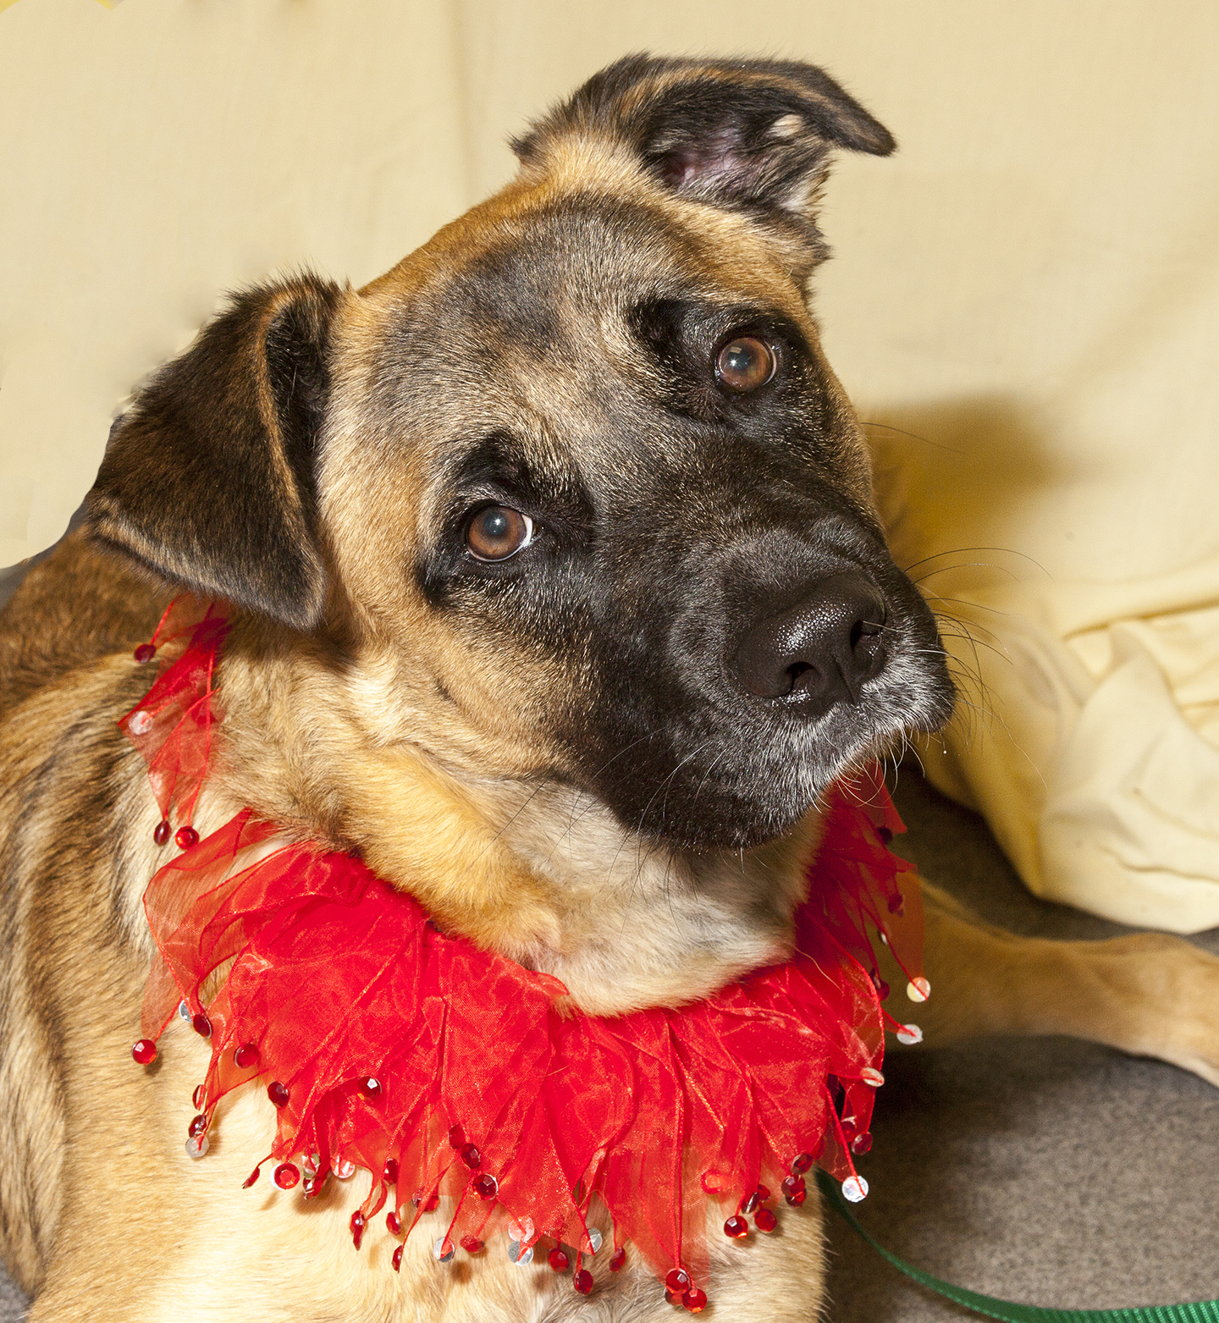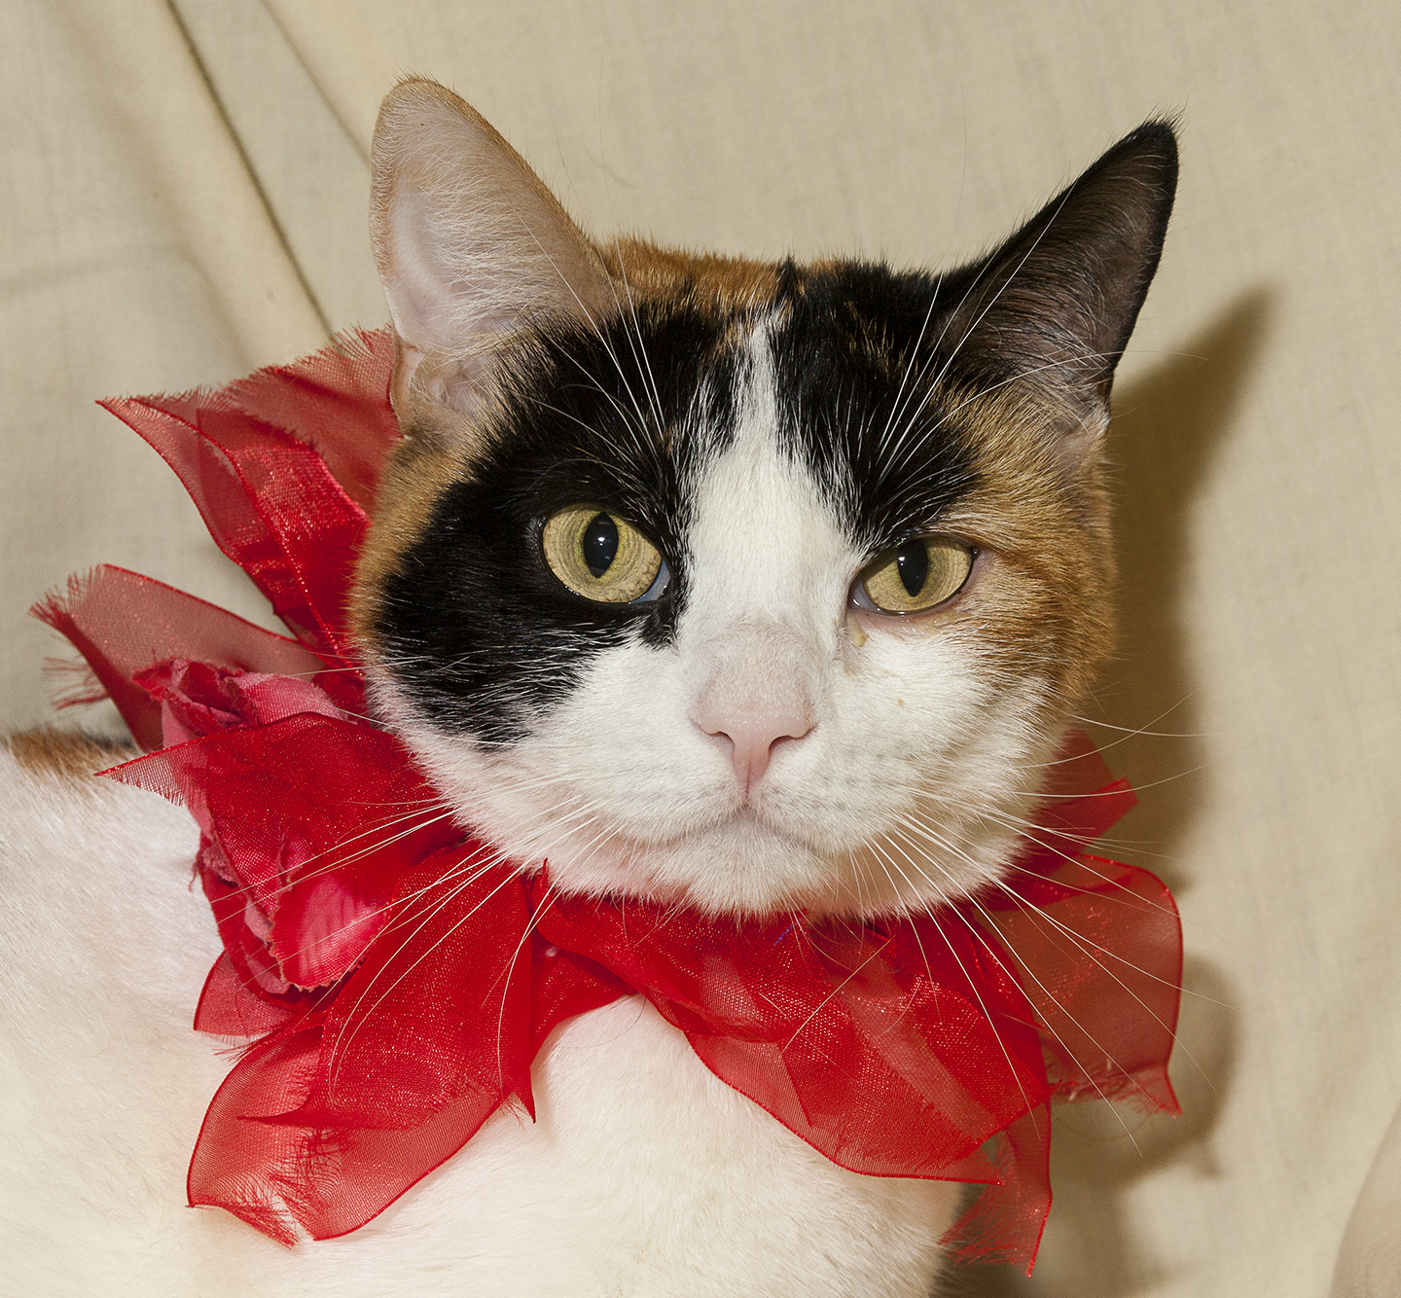

CRITTER CORNER
www.CritterCorner.org
Why not start your pet search at your local county animal shelter? For more information about our
featured pets, call 732-657-8086 and/or visit the Petfinder site at http://www.petfinder.com/shelters/NJ62.html

We have a number of kittens, cats, smaller dogs, and breeds at the shelter.
If you've been thinking about adopting - now is the time. Adopt a pet; save a life.

Adopt a Pet, Save a Life! Alll of our pets are vaccinated, neutered, and chipped before being adopted? Adopting a pet is not only a great way to find your new best friend; it’s also a great value!

Marley— Shepherd Mix
Marley and Me!

Marley is a 7 month old, female, brown and tan, Shepherd mix. Marley is amazing! She is friendly, affectionate, and smart.. Marley is very calm for such a young dog. She has lived with other dogs and would do well in a home with children over 10. Call 732-657-8086 to find out more.

Garland—Calico DSH
So Beautiful!

Garland is a beautiful, adult, female, white/black/tan Calico domestic short hair (DSH). Garland is a sweet, loving, serene little girl. And she is so beautiful! Garland is a wonderful pet and will make a super companion. Call 732-657-8086 to find out more.

This is an independent publication by Mitch Geier and Betsy Lane and is
not meant to be construed as an official publication of the Ocean County Health Department.
12/22/2013
Ocean County Animal Facility

Northern Ocean County Animal Facility Southern Ocean County Animal Facility
615 Freemont Avenue 360 Haywood Road
Jackson, NJ 08527 Manahawkin, NJ 08050
    - 609-978-0127

Featured pets are at the Ocean County Animal Facility-North—open 7 days a week (except holidays) from 1 PM to 4 PM and 1 PM to 6:30 PM Wednesdays —and can be reached at 732-657-8086.


