Love at First Bark:
How a dog with no home and a boy with autism found each other
Article by: Betsy Lane Photos by: Mitch Geier
When the Molokie family of Cream Ridge, New Jersey considered adopting a dog their first thought was how their son Kevin would adjust. Kevin has been diagnosed with autism and while he has pets - cats, a toad, and fish - he was wary of dogs. After much consideration, the family went to the Ocean County Animal Facility North in Jackson to see what dogs were available for adoption.
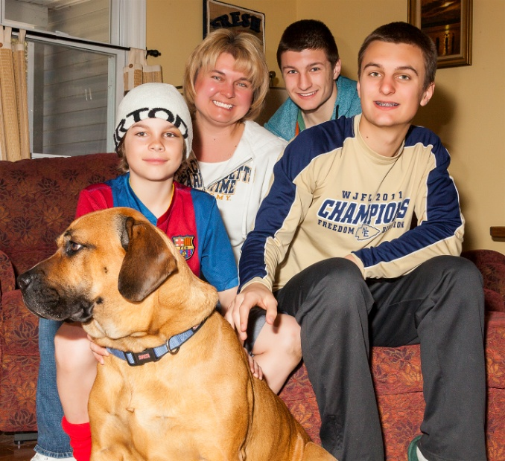
The Molokie’s had high praise for the staff at the Ocean County Animal Facility. The shelter staff members who worked with the family to help them select a dog were patient, considerate, helpful, and encouraging. Mother, Vicki, remembered that when they met the dog they eventually adopted (a female Bull Mastiff mix) that she immediately won over everyone in the family, except Kevin. Vicki noted that the dog "knew" she had to win over Kevin - and she did.
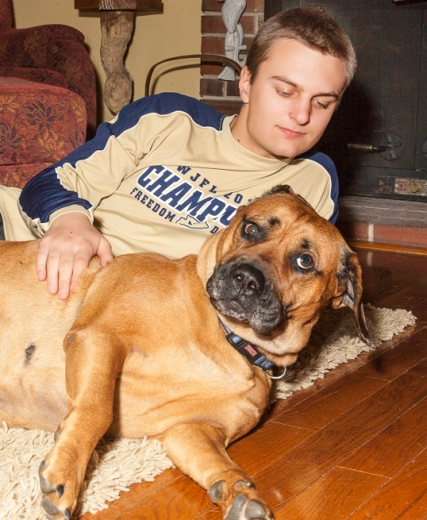
Three months have passed since the Molokie's brought the Bull Mastiff mix home. The now pampered pet was named Butkus by Kevin after Rocky Balboas' English Mastiff from the Rocky films. Butkus seems completely at home in the Molokie household. Kevin and Butkus have developed a strong friendship and Kevin has shifted from a boy who didn't like dogs to telling Butkus, "You know, you’re really an OK dog and I love you so much."
The Molokie's (from left) -- Dog-Butkus, Nephew-Connor, Mother-Vicki, Son-Ryan, and Son-Kevin

The entire family, mom-Vicki, dad-Leon, older brother-Ryan, nephew-Connor, and Kevin have been actively training Butkus. Friend, neighbor, and trainer, Lorie Citarella has been helping the Molokie's train the dog and she has seen tremendous progress. Kevin is now comfortable walking Butkus and controlling her when they encounter another dog. He is also able to communicate to Butkus that she can stop barking -- a significant step since Kevin doesn't like barking dogs.
What has been the biggest impact of bringing Butkus into the Molokie family for Kevin? "Confidence and companionship," is the difference that Lori Citarella sees in Kevin. She notes that the entire family works together to support each other in training their dog. Kevin has grown so much in his comfort level and ability to control Butkus. "What a wonderful family," is Lori's strongest impression.
We couldn't agree more!
Kevin gives Butkus a belly rub -- one of her favorite things.

